ChemOffice Enterprise Search Service

Revision History
Date | Revision | Description | Contributors
10/10/06 | v.1 | Initial draft | Leandro Lillo, Facundo Galdeano, Cecilia Amadio
10/16/06 | v.2 | Comments, answers | David Gosalvez, Leah Bialic
10/31/06 | v.3 | More answers | David Gosalvez
12/4/2006 | v.4 | Update | Leandro Lillo

Copyright © 2006 CambridgeSoft Corporation. Cambridge, Massachusetts.
All Rights Reserved

This document is the property of CambridgeSoft Corporation and is intended for internal use only. Reproduction or transmission of this document in any form, in whole or in part, without prior written permission of CambridgeSoft Corporation is prohibited.

Initial Design - Search Service
Our approach to the initial design of the search Service was to analyze the methods you defined as the interface of the service, individually. In this first approach we have exploded GetHitList.

Methods Responsabilities

GetHitList
This method is responsible of creating the initial query based upon searchCriteria (generated based upon user input on search form) and dataView xmls. After execution its results, a list of ids that match the criteria, are to be stored into a HITLIST table.
The Method returns the count of matches, and the id of the resulting hitlist.

GetData
This method is responsible for returning sets of data associated with previously persisted Hit Lists. Based upon a HitListID and a resultCriteria, this method has to create a query that will be used to fill a dataset. This dataset will be returned to the user together with Paging info and HitListInfo, in a SearchResponse Object.

DoSearch
This method will mix the functionality of GetHitList and GetData. It will make the entire process: perform the search, insert into hitlist (and remember the id), retrieve the actual data and return it to the caller. This method returns a SearchResponse object.
It will only call the other two functions.

DoSearchXML
This method is a wrapper for DoSearch, but returns a string with the SearchResponse object serialized in XML.

GetCOEHitList – Disregarded: it’s a responsibility of the Hitlist Service
This method will retrieve the primary keys that match a previously persisted HitListid from the database and return it to the caller. It doesn’t execute any insertion into HitList, just retrieval of primary keys associated with a previously persisted HitList.

Note: As we understood the last Method (GetCOEHitList) was a requirement. It differs from GetHitList in that it doesn’t insert into HITLIST table, but retrieves its values.
GetHitList returns HitListInfo (only HitListId and count) whether GetCOEHitList returns primary keys arrays.
However, the naming we are using doesn’t reflect these differences. Let us know what you think.

Implementation

GetHitList

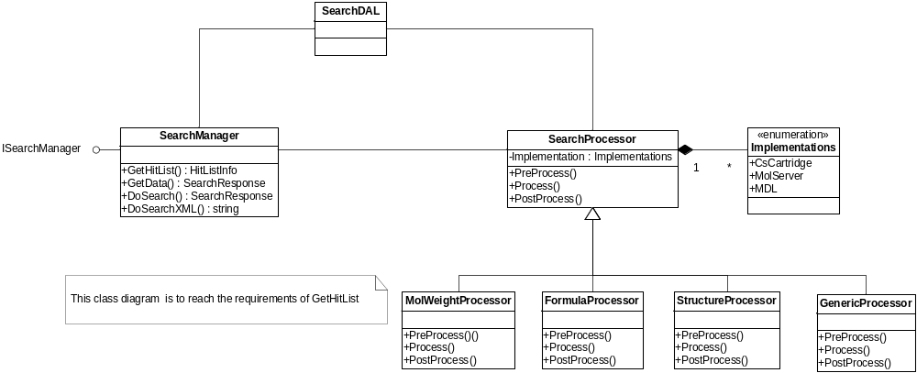

The SearchManager class will expose the methods as you required: GetHitList, GetData, DoSearch and DoSearchXML
DGB: By convention, we would like the SearchManager class to be called SearchManager. While you may want to have more descriptive names further down stream, I think the name GetHitlist is appropriate for the publicly exposed method. The caller has no concept of things that occur behind the scenes, such as hits being inserted into hitlist tables. They want to perform a search and receive a hitlist. We don’t understand what the purpose of SearchDAL is in the diagram. The entire implementation of the Search Service should be part of the Framework.dll, as are all other COE Services.

Note: We have corrected the names. Now it’s clear that SearchDll is SearchDal, not a .dll file (that was the original idea).

The main idea is to delegate the real work to helper classes, one for each method. No complex logic will be performed inside the SearchManager.

The schema of helpers was discarded: It was not necessary as the framework defines Interfaces for each Service, so we think that serves the same purpose. Implementing the methods in helpers would render SearchManager class quite dull, as it’s no longer defining the methods signatures and names.

In the case of GetHitList, the service will implement the very method GetHitList following a template pattern: Taking advantage of generic (or static) parts of the algorithm for retrieving the hitlist, but fullfilling the specific (or dynamic) requirements for each searchCriteriaItem.
This method is organized in three big steps: Preprocess – Process – PostProcess. The method will have to perform certain common tasks on every one of these steps. Also every searchCriteriaItem will have its own preprocess implentation (where it may have to insert temporary data to DB) to be called when required, process implementation (where it ay have to modify the searchCriteria, replacing its xml tag), and postprocess implementation (where it may have to delete temporary files).
The whole process will be executed in the context of a single db transaction (as needed for some temporary table implementations).

Let’s navigate through a concrete case, structure criteria:
The static part of the template, general to every searchCriteriaItem would be:
GetHitList(…) {
For each chemical criteria item in SearchCriteria {
Instanciate the corresponding SearchProcessor object;
Object.PreProcess();
}
Replace chemical Criterias with a concatenation of object.Process()

Generate Results XML:
Connect to HitListService and obtain an Identifier
Obtain Base Table and Base Table Primary Key from DataView

Instanciate a Query Object from SQLGenerator Builder and generated XMLS.
Obtain an Insert Object from SQLGenerator, using the generated query.
Obtain a DB Interface, and execute the insert.
Finally
For each object in SearchProcessors
Object.PostProcess()
}

The dynamic or specific part for StructureCriteria would be:
StructureProcessor : SearchProcessor {
Preprocess() {
CsCartridge:
Insert Structure into temporary table and remember id
MolServer:
Instanciate MolServer
Save Structure to temporary file.
…
}
Process() {
csCartridge:
return “<CsCartridgeStructure idTemp = “x” …”;
MolServer:
…
}
PostProcess(){
MolServer:
Delete Temporary files.
CSCartridge:
…
}
}

The static part gurantees the execution of Pre-Pro-Post steps for each search criteria item. The criteria specific implementation is fleshed out in the specific processor implementation.
The main role of the Pro step is to generate/modify the xml so that it can be consumed by the sqlGenerator. We must keep in mind that multiple criteria may sent at once and the result of all Pro steps should lead to search criteria xml (or object) that can be readily executable by the generator. The Pre and Post steps are for buildup and tear down of auxiliary processes (molserver searches, temptables…)

DGB: Most search criteria items do not require any change to the searchCriteria xml (or object). I think the most elegant way to address this is to have a base or generic SearchProcessor that does nothing in all three steps. There should be logic in the code, such as a switch statement that will direct special criteria, such as ChemicalSearch to the appropriate SearchProcessor. I am pretty sure that there will be other, non-chemical search criteria types that will require specialized processor. The case of full text searching via MS Indexing service in SQLServer databases comes to mind…

Note: Base class ChemicalProcessor was renamed to SearchProcessor and a GenericProcessor class was introduced as a dummy Processor. Non chemical search criteria may implement a custom processor if required, or use the generic processor otherwise.

How will the MolServerHeper fit into the DAL existing interface, wich provides methods like GetConnection, ExecuteDataSet, ExecuteNonquery, etc.? Will we have to adapt the wrapper and abstract it to expose this interface, or will we use a GetConnectionString approach and interact directly with MolServerHelper? As we undersand the wrapper, we think the second choice would be more practique.

DGB: We think the boundary should be drawn such that the DALManager will return an object that represents an open connection to the database. In the case of Oracle this object allows for the execution of commands such as ExecuteDataSet or ExecuteNoQuery. In the case of Access and SQL Server the object is more complex, because it represent a connection to two databases: 1) Relational; 2) Chemical. The relational part is totally equivalent to the Oracle case, with similar execution methods provides. The chemical part is represented by a ChemConnection object within the Database object. The ChemConnection object should be a MolServerHelper object created and opened by the DALManager and handed back to the SerachService. The SearchService will know how to use this MolServerHelper object to perform its tasks against the mst file. It will however, never know anything about the connection string or the specific location of the file. This will require that you (Facundo and Leandro) extend both the current MolServerHelper and DALManager code to suit our needs. The MolServerHelper and MolServerWrapper are all yours to evolve. Please coordinate with Leah for extensions of the DALManager layer, as she may be simulataneously working there.

Note: See MolServer document.

GetData
This method is simpler than the previous. At first sight, it seems it doesn’t need a template pattern to accomplish the task. We have faced a number of questions that we need to solve in order to continue into a deeper design.

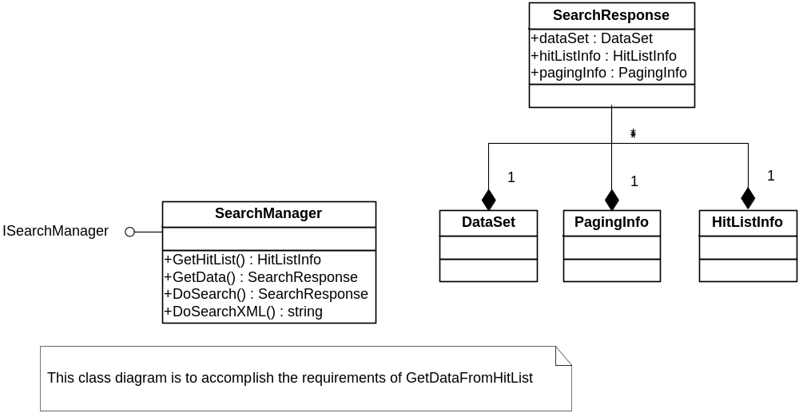

DGB: Leah and I settled on renaming the GetDataFromHitlist() to the simpler name GetHitlist(). I agree that no template pattern is required here. The key tasks in this method are: 1) Modify the resultsCriteria xml (or object), if necessary; 2) Use SqlGen + DALManager to obtain ADO.Net Dataset; 3) Set the pagingInfo object ; 4) populate dataset with structure, formula, and molweight from MolServer; if necessary.

Note: We don’t understand. Will there be two overloaded methods that have completely different purposes, but with the same name? We have written the responsibilities of the methods as we understand them, so that we can make this point clearer. See Responsibilities.

DGB: This was a typo on my part. We wanted to rename GetDataFromHitlist() to the simpler name GetData(). The responsibilities of GetHitList and GetDataFromHitlist are well defined above. It’s just the name of the latter that changes to GetData()

The skeleton of GetData () method would be as follows:
The GetData Method will have the responsibility of inserting the HitList Table to the DataView. This way the insertion into hitlist table schema is encapsulated by the search service.

CSCartridge:
Generate SearchCriteria
Insert HitList Table into DataView.
Obtain query from SQLGenerator
Add Paging info to query (whether programmatically or with xml, in wich case we should do this step before and define the xml syntax)
Retrieve ORA Connection
Execute Query
Fill DataSet (No further actions are required to fill the dataset)

MolServer:
Parse resultCriteria and split it into Non Chemical Criteria and Chemical Criteria. Translate the latter to add the information we will need later when replacing chemical functions.
Generate SearchCriteria
Insert HitList Table into DataView
Obtain query from SQLGenerator using non chemical criteria and translated chemical products.
Add Paging info to query (whether programmatically or with xml, in wich case we should do this step before and define the xml syntax)
Retrieve MDB Connection
Fill DataSet
Retrieve MolServer (MST) Connection ← View MolServer document.

Iterate for each chemical criteria {
Structure:
Create new dataset column
Iterate for each row belonging to the dataset {
Fill searchInfo (molID)
Obtain Structure

DGB: Convert structure to Base64CDX. This will require extending MolServerHelper and MolServerWrapper to effect the conversion from MolServerMolecule to base64.

Insert structure to DataSet row
}
MolWeigth:
Create new dataset column
Iterate for each row belonging to the dataset {
Fill searchInfo (molID)
Obtain MolWeight
Insert structure to DataSet row
}

Formula:
…
}
Return DataSet

The search Service doesn’t distinguish amongst DataBases, but implementations (CSCartridge, MolServer, MDL, etc.).
Will it be possible to mix different implementations on the same application: some criteria using CSCartridge, other using MDL, other using MolServer?

DGB: For now, you can think as a set of searchCriteria as belonging to one and only one database, which guarantees that they use a unified implemention. No mixing of RDBMS or chemical search engines. Later on, you will see a case, called Global Search, which will take a single set of searchCriteria and refactor them into two or more sets of criteria, each to be sent to it’s own database backend. This will happen in a GlobalSearch method to be implemented in the SearchManager, but this method will result in the execution of multiple, sequential, individual searches. There will be no mixing of Cartridge and MolServer cases within one search call.

How do we identify the implementation: will the names be unique in any implementation scope, have an attribute indicating it, will it be global to the formgroup, the application, …?

DGB: There will be an “application” or “databasekey” which will determine the implementation via the app.config file. The DALManager Layer will take care of this. The SearchService should know what datastore is dealing with via the DALManager.

The “database” object provided by the DALManager should provide properties to answer things like the Chemical Search engine (Cartridge vs. MolServer) that will need to be used.

Note: See MolServer Document

How to handle user defined resultCriteriaItems (located in separated assemblies) in case we have to perform custom actions at this point. We have assumed that no actions must be performed. If special actions are to be done, then probably that’s because the resultCriteria should be built-in instead of user-defined.

DGB: This question needs clarification. I don’t know what you mean by user-defined and built-in.

Note: By user defined we refer to the resultCriteriaItems that the user can provide in a separate assembly. Those that are defined in SelectClauseClassMappings.xml.
By Built-in we refer to those that are provided by SQLGenerator natively, and are located in the same assembly.
Do we have to design searchManager keeping in mind extensibility?

DGB: resultCriteriaItems, whether native or custom should result in valid SQL to be included in the SELECT clause. I don’t think that the searchManager needs to know anything about this. It will get an executable Select clause from SQLGenerator. It should be unaware of how the SQL is generated in the lower layer.

Where are we going to handle paging? We believe paging is inherent to GetDataFromHitList. Creating and executing queries (at GetHitList() level) for every paging event would be inefficient. How are we going to map the required information to the query: programmatically or via xml?

DGB: In the initial implementation, each Search request will specify the desired page (first-last-count triad). This will drive the generation of the appropriate SQL that will join the correct section of the hitlist. This is simple, but inefficient. Note that it may we may want/need to add a column to the coehitlist table to track hitnumber and possibly an order column to deal with sorting of hits.

In a second implementation, the caller can specify “keep-alive”. This would be an indication for the search service to execute sql that does not restrict to a section of the coehitlist. Since this may result in huge result sets, the fetching of data from the DB to the middle tier must be carefully managed by ensuring that only the requested page is returned. Subsequent paging request on an “alive” search will simply require additional fetching from the previously obtain database cursor. Note that while this implementation will be much more efficient in terms of paging, it will require the service to become state full and to maintain “caller specific” long lived connections (and cursors).

Note: We understand the global idea, but could you further explain the meaning of hitnumber and ordercolumn?

DGB: The current design persists only two columns to the hitlist: ID and hitlistID. We have requirements to return a particular section of the hitlist as well as to return hits in a particular order. It is possible that the implementation of these requires may benefit from storing one more column in the hitlist table. For example, by storing the ordinal number of each hit, it is simpler to return a particular chuck of hits. This extra column can be called “hitnumber” or “order”

How will we handle the event of needing a service that’s not yet implemented? We’re going to create stubs. How about the tasks performed are complex? We’ll have to see each case as we go on.

DGB: The goal is to keep you moving forward. In some cases, a stubbed or hardcoded return from a non existing service will be best. For example, this could be the case for getting a hitlistID from the hitlist service. In other cases, we may ask you flesh out the implementation of the missing service. This could be the case of DALManager MolServerHelper.

